***EQUIFAX***

CMS Fusion

**REPORTING & INQUIRY POSTING**

**DOCUMENTATION**

Table of Contents

1. REPORTING 4

1.1 Execute SAS 5

1.2 Quick Frequency 5

1.3 Standard Reports 6

1.4 Project Stats 6

1.5 View All Reports 7

1.6 FICO Reports 7

2. Summary 8

3. Inquiry Posting 8

3.1 Post Inquiry 9

3.1.1 Record Type 10

3.1.2 Posting Information 10

**Updates**

|  |  |  |  |  |
| --- | --- | --- | --- | --- |
| **Date** | **Story** | **Requirement** | **Section** | **Modified by** |
| 12/03/2018 | Sprint60(CF2-3135) | Inquiry Posting - add MLA ID to Inquiry Post input file | 3.1 Post Inquiry | Varnika Priydarshini |
|  |  |  |  |  |
|  |  |  |  |  |
|  |  |  |  |  |
|  |  |  |  |  |
|  |  |  |  |  |

# **1. REPORTING**

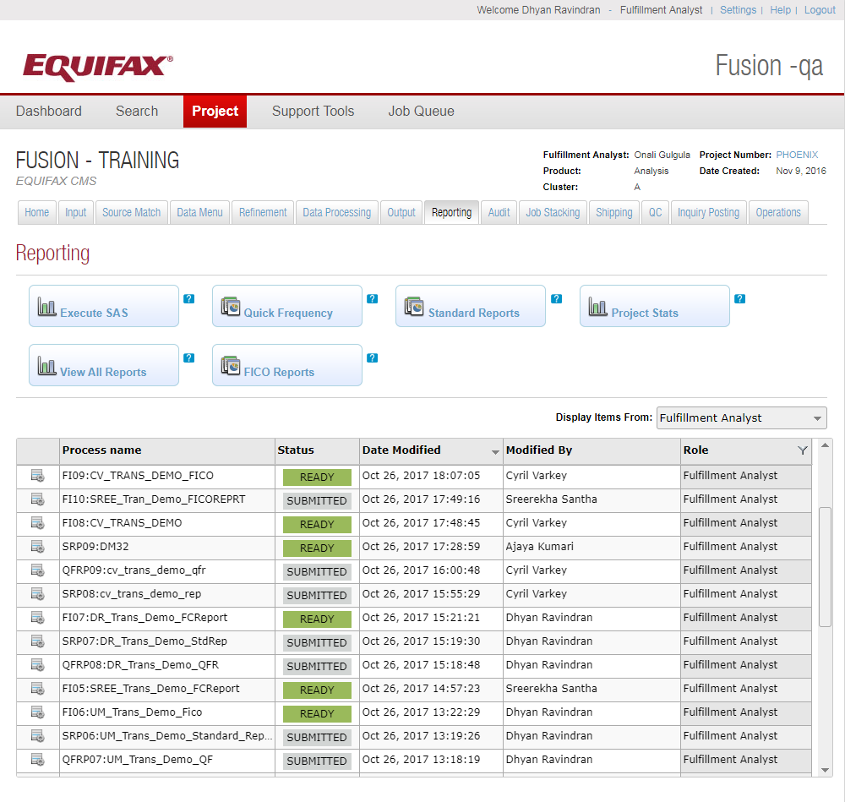

Reporting is basically used to generate Standard Reports and /or SAS (Custom) Reports.

Different type of reports is:-

## **1.1 Execute SAS**

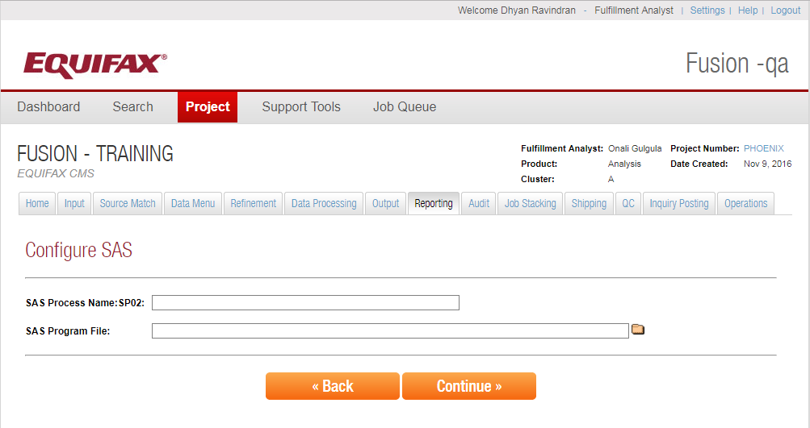

SAS is a third party company that has a report programming product. Write a SAS program which is run by fusion similar to AP module. The input can be a file or the table. Based on the input SAS program it will create the report. Parameter can be defined in input SAS program.

## **1.2 Quick Frequency**

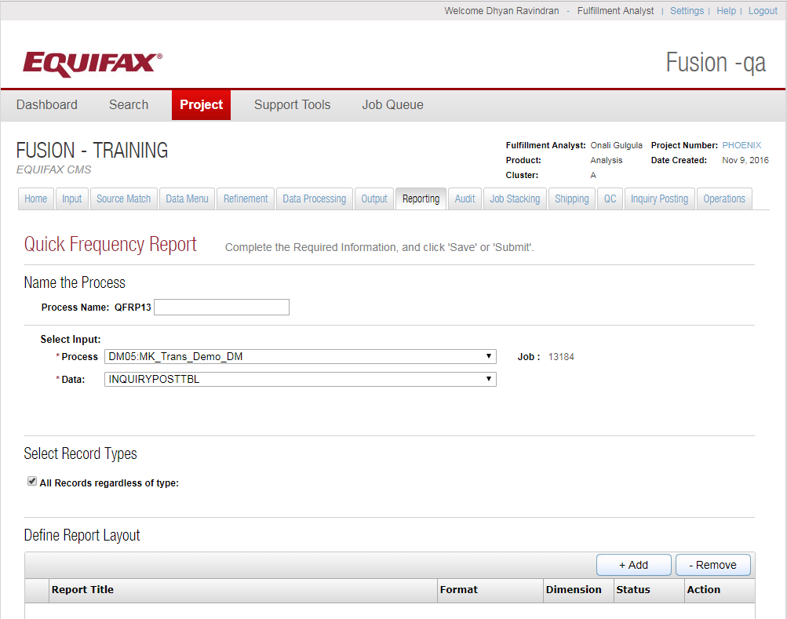

Distribution report or quick report. Configurable Multi-Dimension Report based on the input tables. Multiple filters can be applied and based on that parameters SAS code will be generated. And SAS code will then be used to generate the report.

## 1.3 Standard Reports

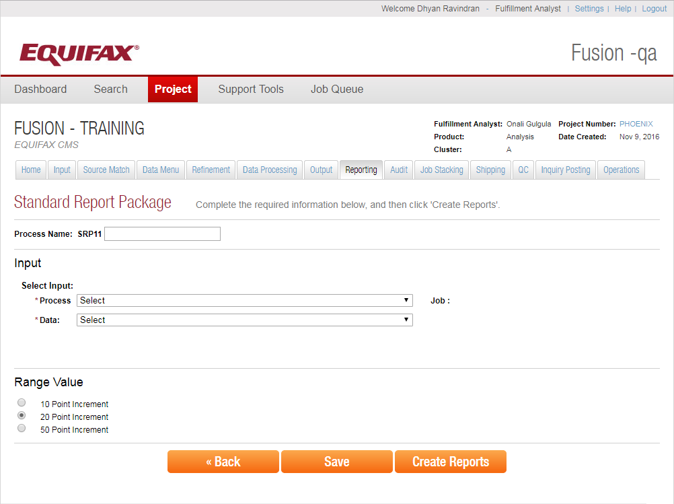

In standard report we don’t have a lot of customization. We can choose Range increment value.

## 1.4 Project Stats

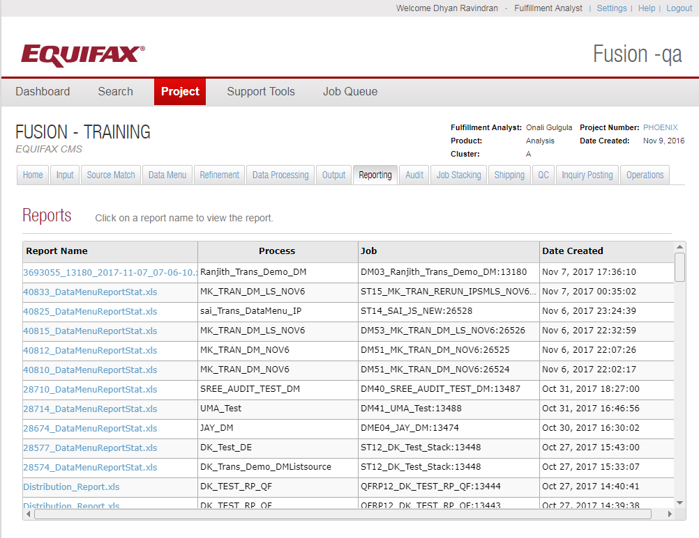

In this select the process and submit it. Generate the stats of all the jobs ran until the selected input process. It will generate the reports on all the steps from start to end. It basically is like a waterfall.

## 1.5 View All Reports

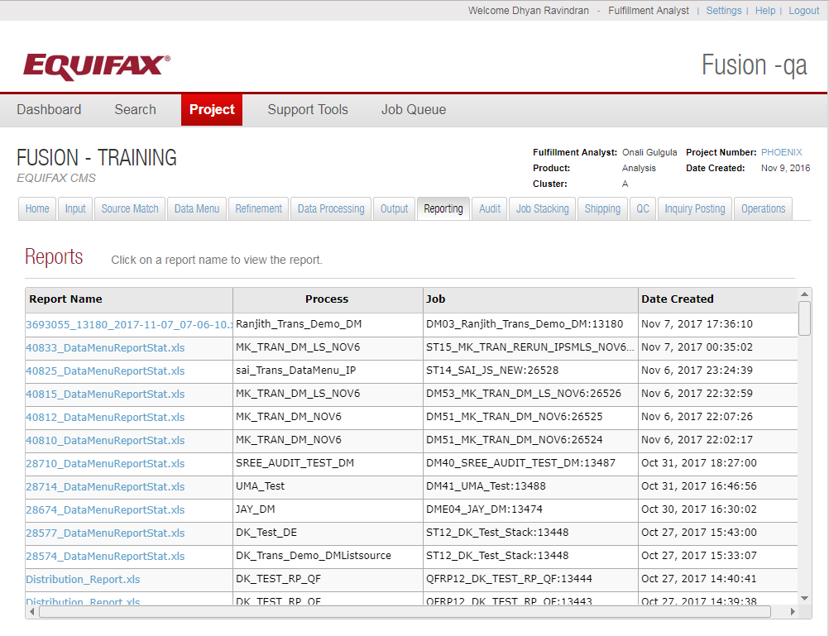

To view the list of all the reports generated.

## 1.6 FICO Reports

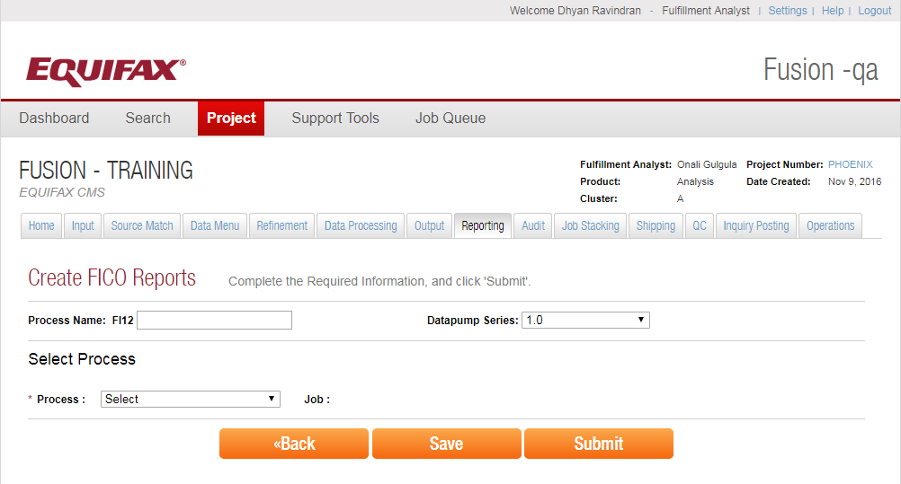

Fair Isaac Company created a model. FICO reports can be generated using that model. It uses pre-configured SAS code to generate distribution report.

# 2. Summary

Reporting is used to generate different kind of reports on the selected jobs.

# **3. Inquiry Posting**

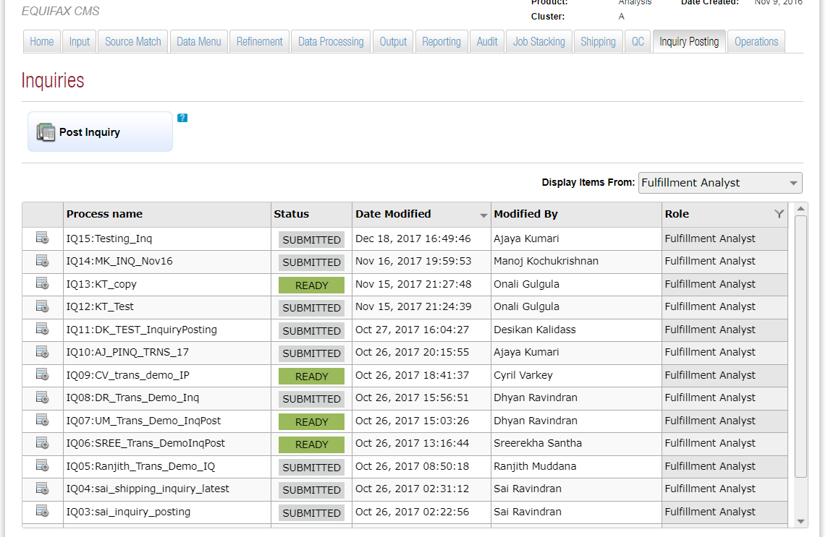

While clicking on the Inquiry Posting tab, it will list the set of processes status for the project and its details

* Process Name–Process name used for the process.
* Status – The status of the process.
* Date Modified – Date on which process is modified.
* Modified By –Name of the Modifier.
* Role – Represents different roles in the application. – Fulfilment Analyst, Programmers.

These will be the role of users who created the process.

* Display Item from - Filters the list of input files based on the role, who created the Input process.
* Duplicate – Provides an option to duplicate an existing process.
* View Summary – There is a high level view of what all options are selected for the process.

## 3.1 Post Inquiry

Inquiry Posting is the process to post the inquiry against the consumer’s record for any type of solicitation. This is just to keep the track of who accessed the records. Only soft inquiry can be posted.

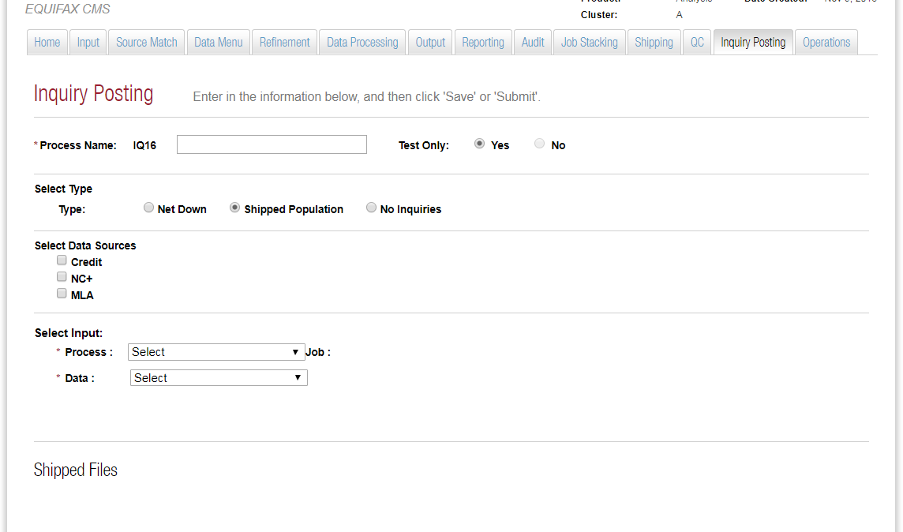

**Process Name:** A process name has a Process Id which is an Auto Generated Id. This will prefix the Process Name that is provided. When generating an input file for posting MLA inquiries, the last 40 bytes is the MLA ID.

**Test Only:** This option when chosen then it won’t update the billing system or online system. It means that no inquiry will be posted against the records.

**Type Selection**: There are 3 types of Inquiry Posting.

**Net Down:** Net Down means consumer is sending back a file with the list of records that they used against the total records shipped to them. So the inquiry will be posted against those records only. The MLA ID for this type comes from the Net Down file.

**Shipped Population:** When we select Shipped Population, inquiry will be posted against the total records shipped. The MLA ID for this comes from the inquiry table.

**No Inquiries:** This type when selected will not be used to post the inquiry against any records but will be used for the project accounting purpose.

**Data Source Selection:** We have Credit, NC+ and MLA data sources to choose from. We can choose which data sources we are posting the inquiry to. We can choose multiple data sources.

**Input Selection:** We have to select input source file and then we have to select the data.

**Shipped date:** We have to choose shipped date.

### 3.1.1 Record Type

This option will be available only when we select type as shipped population to filter the records that we want to post the inquiry to. We can choose all records or a particular (accepted) type of records for which we want to post the inquiry for.

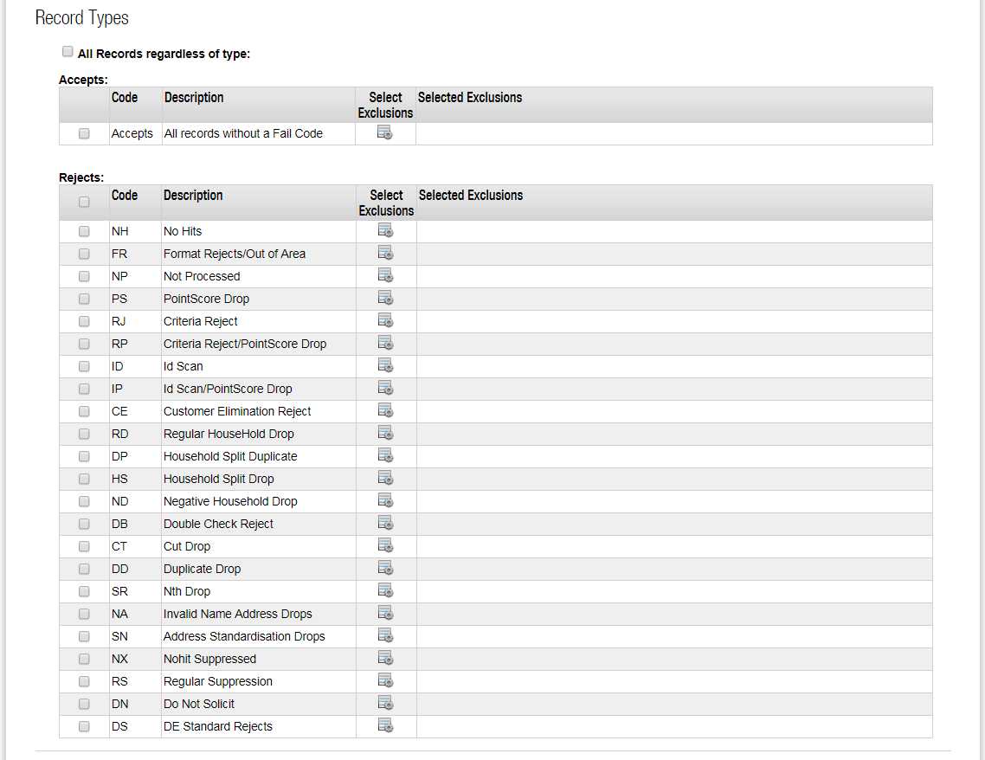

### 3.1.2 Posting Information

When we choose type as Net Down or shipped population then we have to provide or select information like project number, type, member ID, date, and NC+ Customer ID number.